
Computer Networks Lab_241L
UW-24-CS-BS-101
Registration NO:
Muhammad Talha_CS.3ndB
Lab Task # 01
UNIVERSITY OF WAH(UOW)

DEPARTMENT OF COMPUTER
SCIENCE

COURSE:

SUBMITTED TO:

Mr. Hassan Shafaqat
SUBMITTED BY:

Task # 1
Arranging everything
- Adding computers on screen
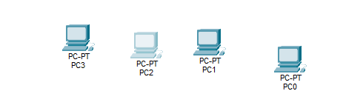

- Adding Laptops on screen
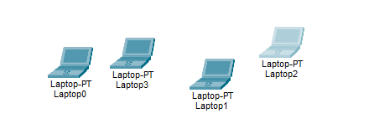

- Adding switch and hub on screen
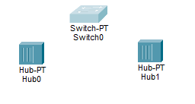
- Arranging everything in order
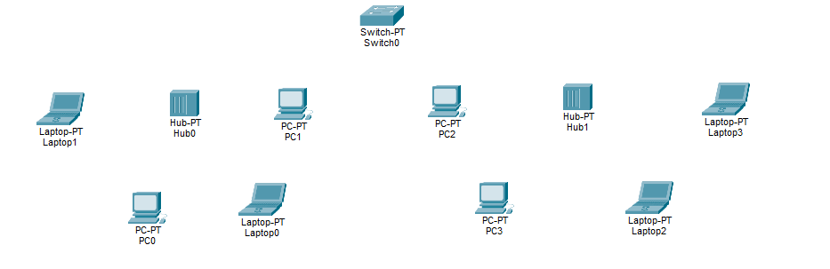
- Attach computer and laptops with hub
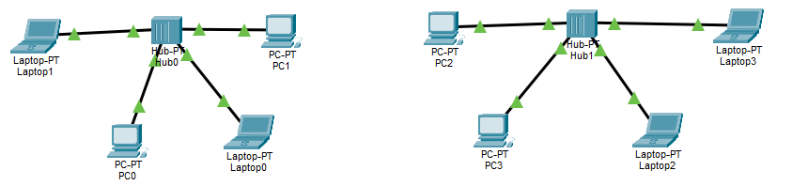

- Attaching hub with switch
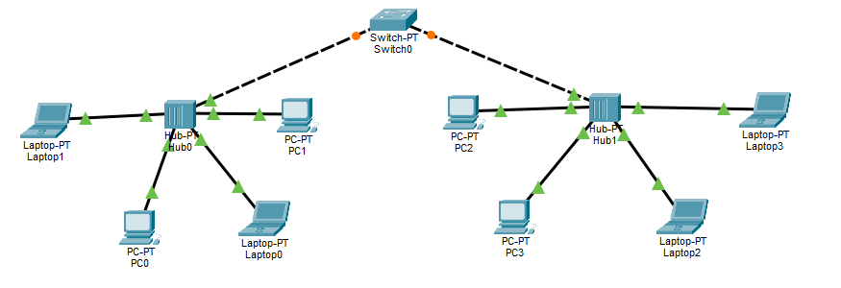
Assigning IP address to each device
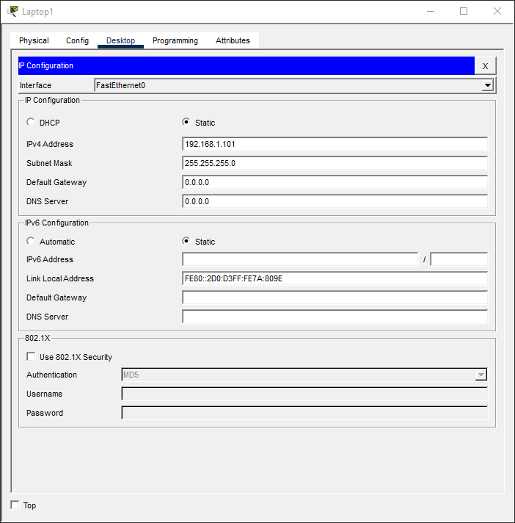

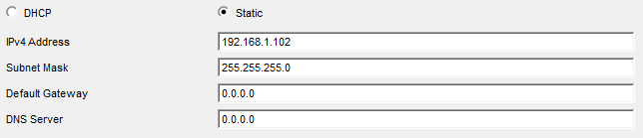
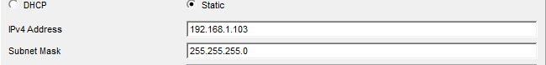
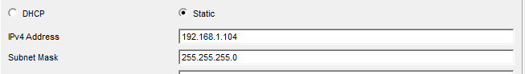
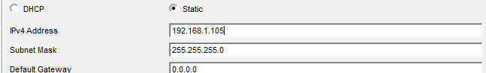
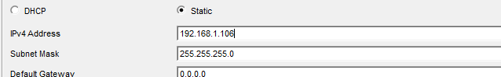
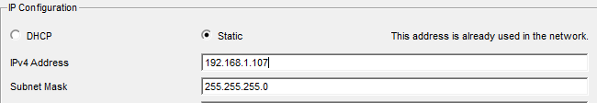
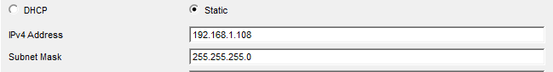
Now Sending Messages to each Node
- From L2 to All:
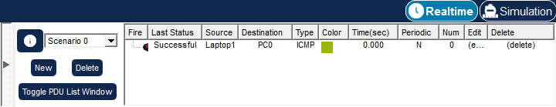

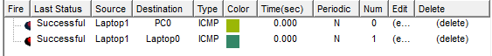

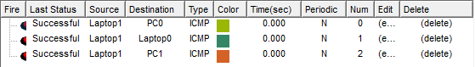

- From PC1 to All:
- From L1 to All:
- From PC2 to All:

- From PC3 to All:
- From PC4 to All:
- From L3 to All:
- From L4 to All:

